 | Mayfield Church of Christ Newsletter |  |  | April 5, 2020
662-869-5558
2348 Hwy 145 – PO Box 129
Saltillo, MS

Welcome to the Mayfield church of Christ. We hope you will join us for worship today (Sunday) at 10:30am on FB live. Please plan for this worship period. Log into Facebook early to have it ready. Please know this avenue of worship is temporary. We feel this is the safest way to worship for the health of everyone currently. Pray for this time to pass where we can physically be together in one place. Unless Jesus comes back first, it will happen. Prepare for that time. |  | Our order of worship will be as follows:  Announcements/Prayer  2 Songs – “Praise Him, Praise Him”, “Nearer Still Nearer”  Sermon – “God Created The Home” (Genesis 2:18-25) Mark Shiers  Song – “I Know That My Redeemer Lives”  Lord’s Supper  “Just As I Am” and prayer |  |  | elders  Lonnie Neaves  Mark Stiles  Mike Miller  Pete Worthey  Deacons  Zak Coats  Jason Kelly  Phillip Lansdell  Mitchell Brazeal  Rorie Coker  Ministers  Mark Shiers 731.608.7774  Adam Miller 662.523.3684  Mayfieldchurchofchrist.com
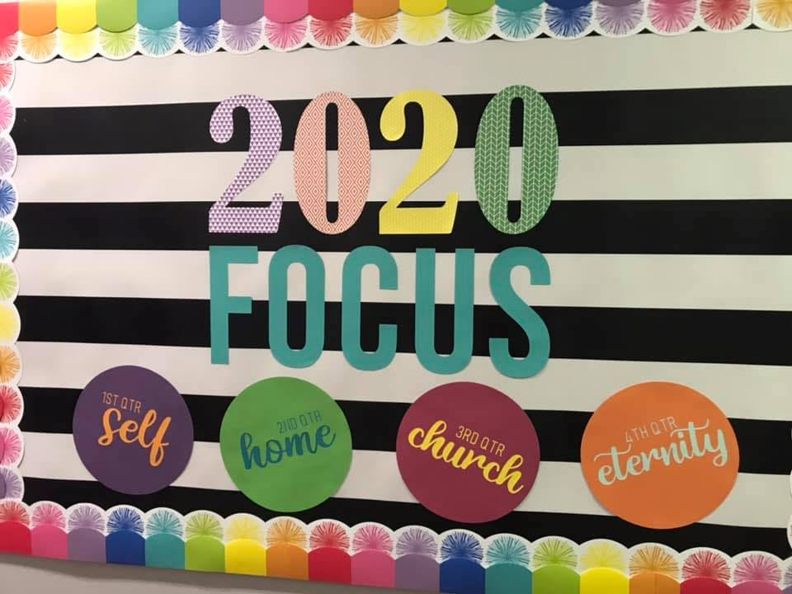

Prayer list
Kindle Sample, Marshall Brazeal, Karen Duncan, Emily Beene, Adrianna Augustine, Dorothy Rowland, Gloria Shiers, Eddie Bishop, Janie Nichols, Hubert & Marie Weathers, All Hospital and Nursing Home patients and personnel, All Doctors and Nurses, All people dealing with Coronavirus and the effects of it, Missionaries, Our nation and its leaders, The church and our elders, servants, and all Christians.
April Birthdays and Anniversaries
Diane Sample – 4th
Vic Hawn – 5th
Jason & Rhonda Kelly – 9th
Brent & Melissa Davidson – 11th
Dorothy Rowland – 12th
Roger & Teresa Cooley – 13th
Alisha Williams – 16th
Kelly Smith – 23rd
Kyle Bond – 25th

